- Move zip file to a desired location on your computer
- Unzip.
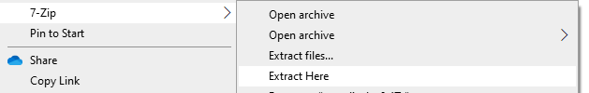
- Inside the unzipped folder click on either px1.html or px2.html
- The emulator will come up in your browser.
- Bookmark it.

Known Limitations:
Not all menus are completed. This is not a finished product but can still be useful (sometimes)

